Quarterly Statistical Release
August 2007, N° 30
This release and other statistical
releases are available on efama’s
website (www.efama.org)

Trends in the European Investment Fund Industry

in the Second Quarter of 2007

and

Results for First Half of 2007

This report was prepared by Bernard Delbecque, Director of Economics and Research

EFAMA
The European Fund and Asset Management Association

Square de Meeûs, 18 - B-1050 BRUXELLES - Tel. 32-2-513.39.69 Fax: 32-2-513.26.43 - e-mail: info@efama.org

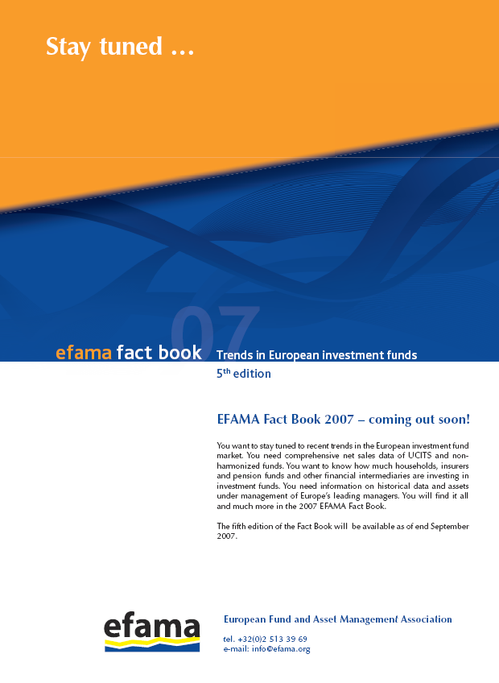

Trends in the UCITS Market
Net Sales by Investment Type

Net flows to UCITS reached EUR 84 billion in the second quarter of 2007, EUR 22 billion less than in the first quarter. A fall in net inflows in money market funds explains most of the difference. Balanced funds recorded the highest level of net inflows (EUR 28 billion), followed by money market funds (EUR 26 billion), “other” UCITS (EUR 23 billion) and bond funds (EUR 12 billion). For the second consecutive quarter, equity funds recorded net outflows, despite buoyant stock markets in the spring. This indicates that investors’ appetite for risk exposure did not recover in the second quarter from the stock market turmoil at the end of February and in early March. This situation is likely to persist in the third quarter as a consequence of the crisis in the US subprime market and the financial contagion to the global credit and stock markets.

For the first half of 2007, total net sales reached EUR 190 billion. Although slightly higher than in the first half of 2005, this level was EUR 49 billion lower than in the first half of 2006. This outcome was driven by the aforementioned fall in investor demand for equity funds. Stronger inflows into money market funds contributed to offset this development, albeit only partially.

Trends in the UCITS Market
Net Sales by Country of Domiciliation

The geographical distribution of net sales observed in the second quarter of 2007 prolonged the trends observed in recent quarters. Luxembourg and France retained their position as top selling fund domiciles in Europe. Thanks to a reported EUR 37 billion increase in home-domiciled UCITS assets, Ireland stood third in this ranking, followed by the United Kingdom.

All other countries, except Italy, Germany and Portugal, reported positive net sales in the second quarter. As long as differences in regulation will continue to give rise to regulatory arbitrage in these countries, UCITS are likely to suffer from competing structured products. In Italy, outflows are also attributable to tax rules penalizing Italian versus foreign-domiciled funds. To get an estimate of the demand for investment funds, it is necessary to take into account the net sales of “round-trip” funds domiciled abroad and of the foreign funds. In Germany, the EUR 2.6 billion outflows from local funds were offset by net inflows into “round-trip” funds domiciled in Luxembourg, which totalled EUR 14.3 billion in the second quarter, of which EUR 11.5 billion benefited money market funds and more than EUR 5 billion guaranteed and other funds using derivatives. The situation was different in Italy, where “round-trip” funds promoted by national providers appeared less capable than in the past to compete with foreign funds and alternative savings products (round-trip funds recorded net inflows of EUR 800 million and foreign funds net inflows of EUR 5.8 billion).

The developments during the first half of 2007 mirrored what happened in the second quarter. The highest amount of new money was invested in Luxembourg (EUR 131 billion, compared to EUR 98 billion and EUR 154 billion in the first half of 2005 and 2006, respectively). France held the second largest share in total net sales in January-June 2007 (EUR 76 billion, compared to EUR 52 billion and EUR 69 billion in the corresponding period of 2005 and 2006).

Trends in the UCITS Market
Net Assets by Investment Type

Total net assets of UCITS grew by 4.2 percent in the second quarter to reach EUR 6,478 billion at end June 2007. About 30 percent of the asset growth was fuelled by net inflows and 70 percent by market appreciation. Against the backdrop of net outflows, the 5.5 percent increase in equity fund assets was a reflection of the strong stock market gains in the second quarter. The increase in “other” UCITS assets was driven by investor demand for France-domiciled funds of hedge funds and “other” UCITS domiciled in Luxembourg.

Since the end of 2006, total assets in UCITS rose by 9 percent, or EUR 537 billion. New money invested in UCITS represented slightly more than 3 percent of UCITS assets at end 2006. Other UCITS enjoyed the strongest asset increase, confirming the attractiveness of funds following a flexible investment strategy and/or using derivatives.

Looking forward, whereas lasting volatility in stock markets will continue hurting net inflows into equity funds, developments in stock markets in 2006 and more recently suggest that stock prices could rebound in the second half of 2007 above the levels prevailing at end June 2007. The interventions of central banks to restore confidence and avoid harm spreading to the real economy should contribute to this outcome. In the fixed-income segment of the fund market, investors are likely to reappraise the risks associated to enhanced money market funds investing in asset-backed securities. The search to safety will benefit funds following more defensive style of investment.

Trends in the UCITS Market
Net Assets by Country of Domiciliation

Looking at the development in the major fund markets, UCITS growth in the second quarter was the strongest in Luxembourg and Ireland, the two European centres for global distribution of UCITS, which administered 38.5 percent of total UCITS assets at end June 2007. France, the United Kingdom and Germany also enjoyed positive UCITS asset growth in the second quarter. At the other end of the spectrum, Italy-domiciled UCITS suffered again from a fall in assets under management.

Elsewhere in Europe, UCITS assets grew by 6 percent in the Nordic countries in the second quarter, with Norway and Finland recording the strongest increase. In Central Europe, UCITS assets rose by 16 percent, thanks to impressive asset growth in Poland and Hungary.

The top five countries in terms of asset growth during the first half of 2007 were: Poland, the United Kingdom (in part thanks to the inclusion of additional institutional funds in the statistics reported by IMA), Liechtenstein, Hungary and Turkey.

Trends in the Non-UCITS Market
Net Sales and Assets by Investment Type

Total assets in the non-UCITS market rose by 3.9 percent in the second quarter to EUR 1,758 billion. This increase was driven by strong growth in French employees savings funds, “other” non-UCITS, especially alternative management funds domiciled in Luxembourg, Switzerland and Italy, and real estate funds. On the other hand, growth in institutional fund assets was subdued, reflecting in part a shift of investor demand in Germany away from “Spezialfonds” towards discretionary portfolio asset management.

Since end 2006, total assets of non-UCITS grew by 9.1 percent, or EUR 147 billion.

Trends in the European Investment Fund Industry
Net Assets by Country of Domiciliation

The combined assets of the investment fund market in Europe, i.e. the market for UCITS and non-UCITS, increased by 4.1% in the second quarter of 2007 to reach EUR 8,236 billion at end June 2007. Thanks to EUR 326 billion increase in assets under management, European investment fund assets passed the EUR 8 trillion threshold for the first time ever.

In absolute terms, the asset growth was strongest in Luxembourg (+EUR 202 billion), the United Kingdom (+EUR 155 billion), France (+EUR 146 billion), Ireland (+EUR 83 billion) and Germany (+EUR 46 billion). It should also be noted that funds domiciled in Luxembourg increased their market share to 24.5 percent, with total assets now above the EUR 2 trillion threshold.

Since end 2006, the European investment fund industry saw its assets rise by 9.1 percent, or EUR 683 billion.

With EUR 6,478 billion invested in UCITS, this segment of the business accounted for 78.7% of the fund market at end June 2007.

By way of illustration, the Dow Jones STOXX 600 index increased by 4.81 percent between 16 August and 23 August 2007.

